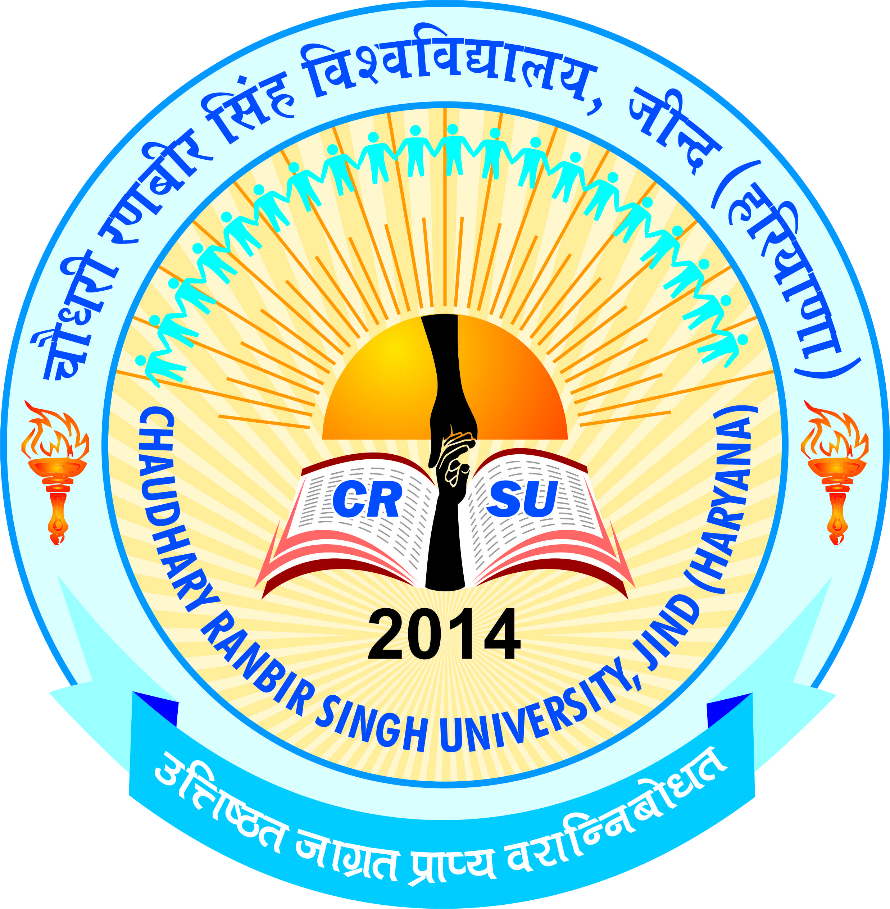 | pkS/kjh j.kchj flag fo'ofo|ky;]thUn  Chaudhary Ranbir Singh University, Jind  (Established by the State Legislature Act 28 of 2014) | 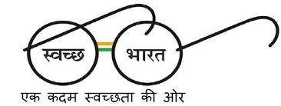

TENDER NOTICE
Printing of Degrees

Chaudhary Ranbir Singh University, Jind invites short term tender for the printing of degrees. The last date and time for the submission of tender/ quotation is upto 29/09/2016 by 5:00pm in the office of the Registrar, CRSU, Jind. The Registrar, CRSU, reserves the right to accept or reject any or all the bids without assigning any reason. The degrees / diploma should be as per given below features :-
- Inclusion of Mother’s Name.
- Adequate Security features including Hologram and Bar – Coding.
- Fire – Proof and Water – Proof papers with the high quality printing for longer life of the degrees.
- Equal spacing at least 0.7” from each side.
- Degrees should be printed in Hindi and English Language.
Send your rates per degree / diploma along with specimen on or before the stated date.

Registrar

